**Part 3**

**Experimental Analysis**

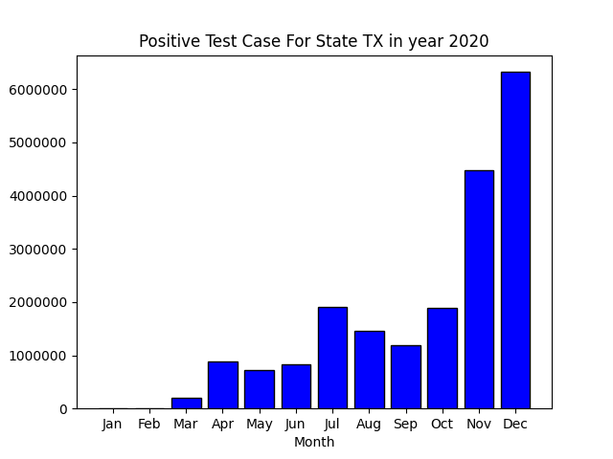



d)

|  |  |
| --- | --- |
| **Epsilon** | **Error** |
| 0,0001 | 658330,4104 |
| 0,001 | 42432,01827 |
| 0,005 | 7229,294678 |
| 0,01 | 3521,014455 |
| 0,05 | 636,0807878 |
| 0,1 | 306,6717455 |
| 1 | 32,844796 |

In the graph above, x axis represents epsilon values and y axis represent measured errors. As it can be clearly seen from the graph and from the table, error decreases as the epsilon increases, which implies that error and epsilon are inversely proportional. Higher error amounts shows that there is a lower probability to obtain the real value from the dataset, which mean the higher the error, the higher the privacy. In addition, the accuracy increases exponentially as the epsilon increases. Therefore, for higher privacy we should use smaller epsilon values.

e)

|  |  |
| --- | --- |
| **N** | **Error** |
| 1 | 32,45454108 |
| 2 | 66,31566028 |
| 4 | 131,4700849 |
| 8 | 248,3457017 |

The graph and the table above contains the results of “N vs Error” experiment. The x axis of the graph represents the N values and y axis represents the Error calculated. As it can clearly seen from the graph and the table error increases as N increases, which implies that N and error are directly proportional. Since higher privacy requires higher error rates, we can say that for higher privacy we need to use higher N values.

g)

The graph above contains the result of the exponential mechanism test. The x axis represents the epsilon values and y axis represents the percent accuracy of the returned value. As it can be seen from the table, the accuracy increases monotonically as the epsilon increases. In addition, amount of increase in accuracy decreases as the epsilon values gets bigger. When we set epsilon as 1 the percent accuracy of the result is 100, which means that there is no privacy for epsilon equals 1. Therefor, we should avoid setting epsilon as 1. For higher privacy levels we need lower accuracy rates, so we should use small epsilon values for high privacy.